Sprint 3 – Agility Design Document

April 18, 2024

Table of Contents

1. Executive Summary 3

1.1 Project Overview 3

1.2 Purpose and Scope of this Specification 3

2. Product/Service Description 3

2.1 Product Context 3

2.2 User Characteristics 3

2.3 Assumptions 3

2.4 Constraints 3

2.5 Dependencies 4

3. Requirements 4

3.1 Functional Requirements 5

3.2 Security 5

3.2.1 Protection 5

3.2.2 Authorization and Authentication 6

3.3 Portability 6

4. Requirements Confirmation/Stakeholder sign-off 6

5. System Design 6

5.1 Algorithm 6

5.2 System Flow 6

5.3 Software 6

5.4 Hardware 6

5.5 Test Plan 7

5.6 Task List/Gantt Chart 7

5.7 Staffing Plan 7

# Executive Summary

## Project Overview

The objective is to program the robot to navigate the obstacle course accurately and safely, avoid all obstacles, roll up ramps with ease, and knock down as many pins as it can with the use of block code and specialized software.

## Purpose and Scope of this Specification

Describe the purpose of this specification and its intended audience. Include a description of what is within the scope what is outside of the scope of these specifications. For example:

In scope

This document addresses requirements related to phase 2 of Project A:

modification of Classification Processing to meet legislative mandate ABC.

modification of Labor Relations Processing to meet legislative mandate ABC.

Out of Scope

The following items in phase 3 of Project A are out of scope:

modification of Classification Processing to meet legislative mandate XYZ.

modification of Labor Relations Processing to meet legislative mandate XYZ.

(Phase 3 will be considered in the development of the requirements for Phase 2, but the Phase 3 requirements will be documented separately.)

# Product/Service Description

## Product Context

The Sphero Edu program allows block code control of the Sphero Bolt Robot utilized in this project. In addition, the product can roll to certain places at predetermined speeds and directions.

## User Characteristics

* University Students
* Entry level Computer Science knowledge

## Assumptions

* Assumes the Sphero Edu software is installed on device
* Assumes that the robot has been calibrated to face the initial direction of movement before commencing the program.

## Constraints

* Size of classroom HH208
* Limited time available in HH208

## Dependencies

* This requirement necessitates the use of the latest version of the Sphero EDU software.
* Requires up to date version of Sphero EDU software.
* Also dependent on objects and markers provided for the sprint.

# Requirements

## Functional Requirements

| Req# | Requirement | Comments | Priority | Date Rvwd | SME Reviewed / Approved |
| --- | --- | --- | --- | --- | --- |
| ENDUR_01 | Travel forward without hitting glass bottle | Simple first step | 1 | 4/18/24 | Approved |
| ENDUR_02 | Roll at a 90-degree angle passing the next object without contact | Increased difficulty lining up second object | 1 | 4/18/24 | Approved |
| ENDUR_03 | Roll at a 0-degree angle passing the next object without contact | Increased difficulty due to having pass 3 objects | 1 | 4/18/24 | Approved |
| ENDUR_04 | Roll at a 90-degree angle at a high speed to get over the ramp | Difficult to set up how fast and where to set up ramp. | 1 | 4/18/24 | Approved |
| ENDUR_05 | Roll at a 225-degree angle at a high speed to knock down the pins | Easier than some of the others due to no objects being avoided | 1 | 4/18/24 | Approved |

## Security

### Protection

The primary safeguard preventing accidental access to the system is the Bluetooth connection established with a specific device. Access to the robot requires establishing a Bluetooth connection, with only one user able to connect at any given time.

### Authorization and Authentication

To grant authorization for robot usage, users are required to authenticate the robot by providing its name through the Sphero Edu Software

## Portability

* Exceptional environmental independence, guaranteeing that the product functions reliably in a variety of networks, operating systems, and production or development environments.
* Deployment across many devices and systems is made easier by compatibility with several platforms, such as Windows, MacOS, Android, iOS, and more.

# Requirements Confirmation/Stakeholder sign-off

|  |  |  |
| --- | --- | --- |
| Meeting Date | Attendees (name and role) | Comments |
| 04/15/24 | Trey H, Trey P, Flavia D | Confirmed all requirements |
| 04/18/24 | Trey H, Trey P, Flavia D | Confirmed all requirements |

# System Design

## Algorithm

* Start
* Step 1: Roll 0 degree at 56 speeds for 2.1 second
* Step 2: Stop
* Step 3: Delay for 1.5 second.
* Step 4: Roll 90 degrees at 58 speed for 2.6 seconds.
* Step 5: Stop
* Step 6: Delay for 1.5 second.
* Step 7: Roll 0 degree at 56 speed for 3.3 seconds
* Step 8: Stop
* Step 9: Delay for 1.5 second.
* Step 10: Roll 90 degrees at 207 speed for 2.08 seconds
* Step 11: Stop
* Step 12: Delay for 2 seconds.
* Step 13: Roll 225 degrees at 151 speed for 4 seconds
* Step 14: Stop
* Done.

## System Flow

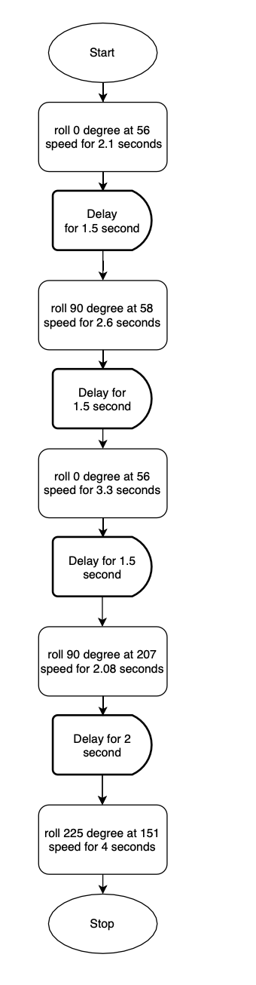

## Software

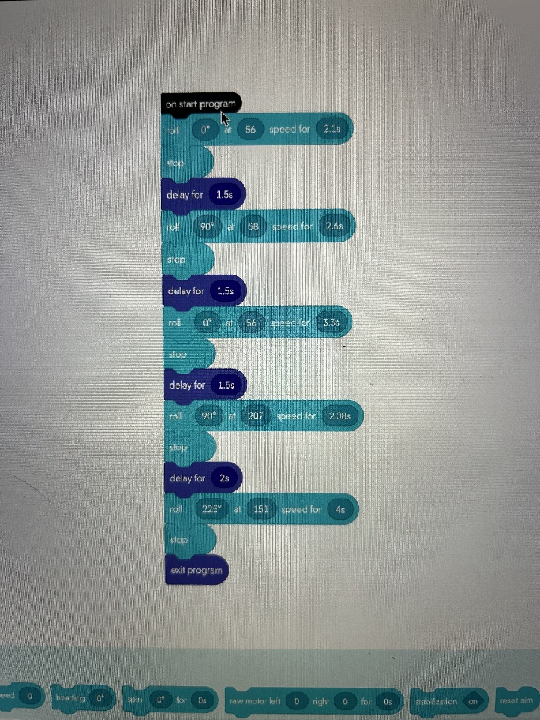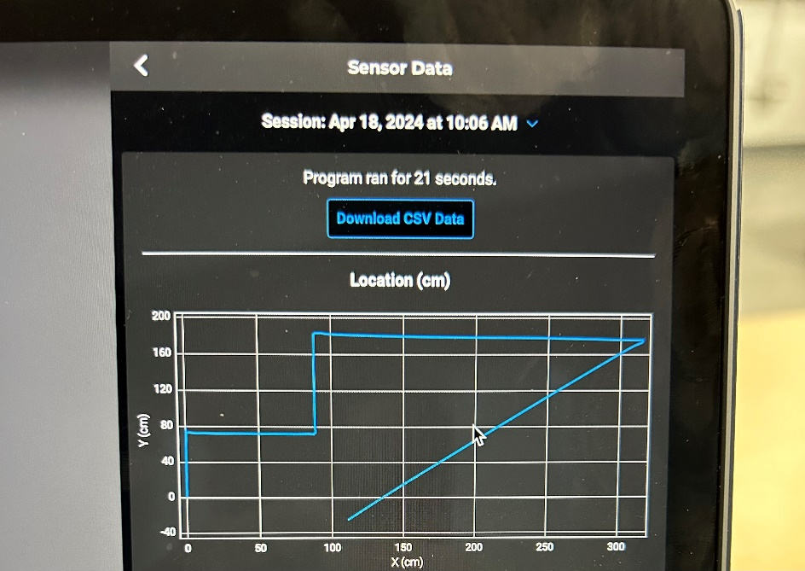

## Hardware

* MacBook Pro
* Sphero edu

## Test Plan

| **Reason for Test Case** | **Test Date** | **Expected Output** | **Observed Output** | **Staff Name** | **Pass/Fail** |
| --- | --- | --- | --- | --- | --- |
| Test if robot goes around first object | 4/18/24 | Robot will go around object without hitting it | The robot hit the object | Trey H, Trey P, Flavia D | Fail |
| Test if robot goes around the first object | 4/18/24 | Robot goes around the object without hitting it | The robot went around the object | Trey H, Flavia D, Trey P | Pass |
| Test if robot goes around the second object | 4/18/24 | Robot goes around both objects | The robot went around both objects | Trey H, Flavia D, Trey P | Pass |
| Test if robot goes around the third object | 4/18/24 | Robot goes around all three objects | The robot went around all three objects | Trey H, Flavia D, Trey P | Pass |
| Test if robot successfully goes over the ramp | 4/18/24 | Robot will roll over the ramp | Robot did not successfully roll up the ramp | Trey H, Flavia D, Trey P | Fail |
| Test if robot successfully goes up the ramp | 4/18/24 | Robot will roll over the ramp | Robot did successfully roll up the ramp | Trey H, Flavia D, Trey P | Pass |
| Test if robot knocks over the pins | 4/18/24 | Robot will knock over all the pins | Robot did successfully knock over all the pins | Trey H, Flavia D, Trey P | Pass |

## Task List/Gantt Chart

## Staffing Plan

| Name | Role | Responsibility | Reports To |
| --- | --- | --- | --- |
| Trey H | Group Member | Algorithm, robot video, system design doc | Flavia D and Trey P |
| Flavia D | Group Member | Fow chart, System design doc | Trey H and Trey P |
| Trey P | Group Member | GitHub Repository owner, System design doc | Trey H and Flavia D |